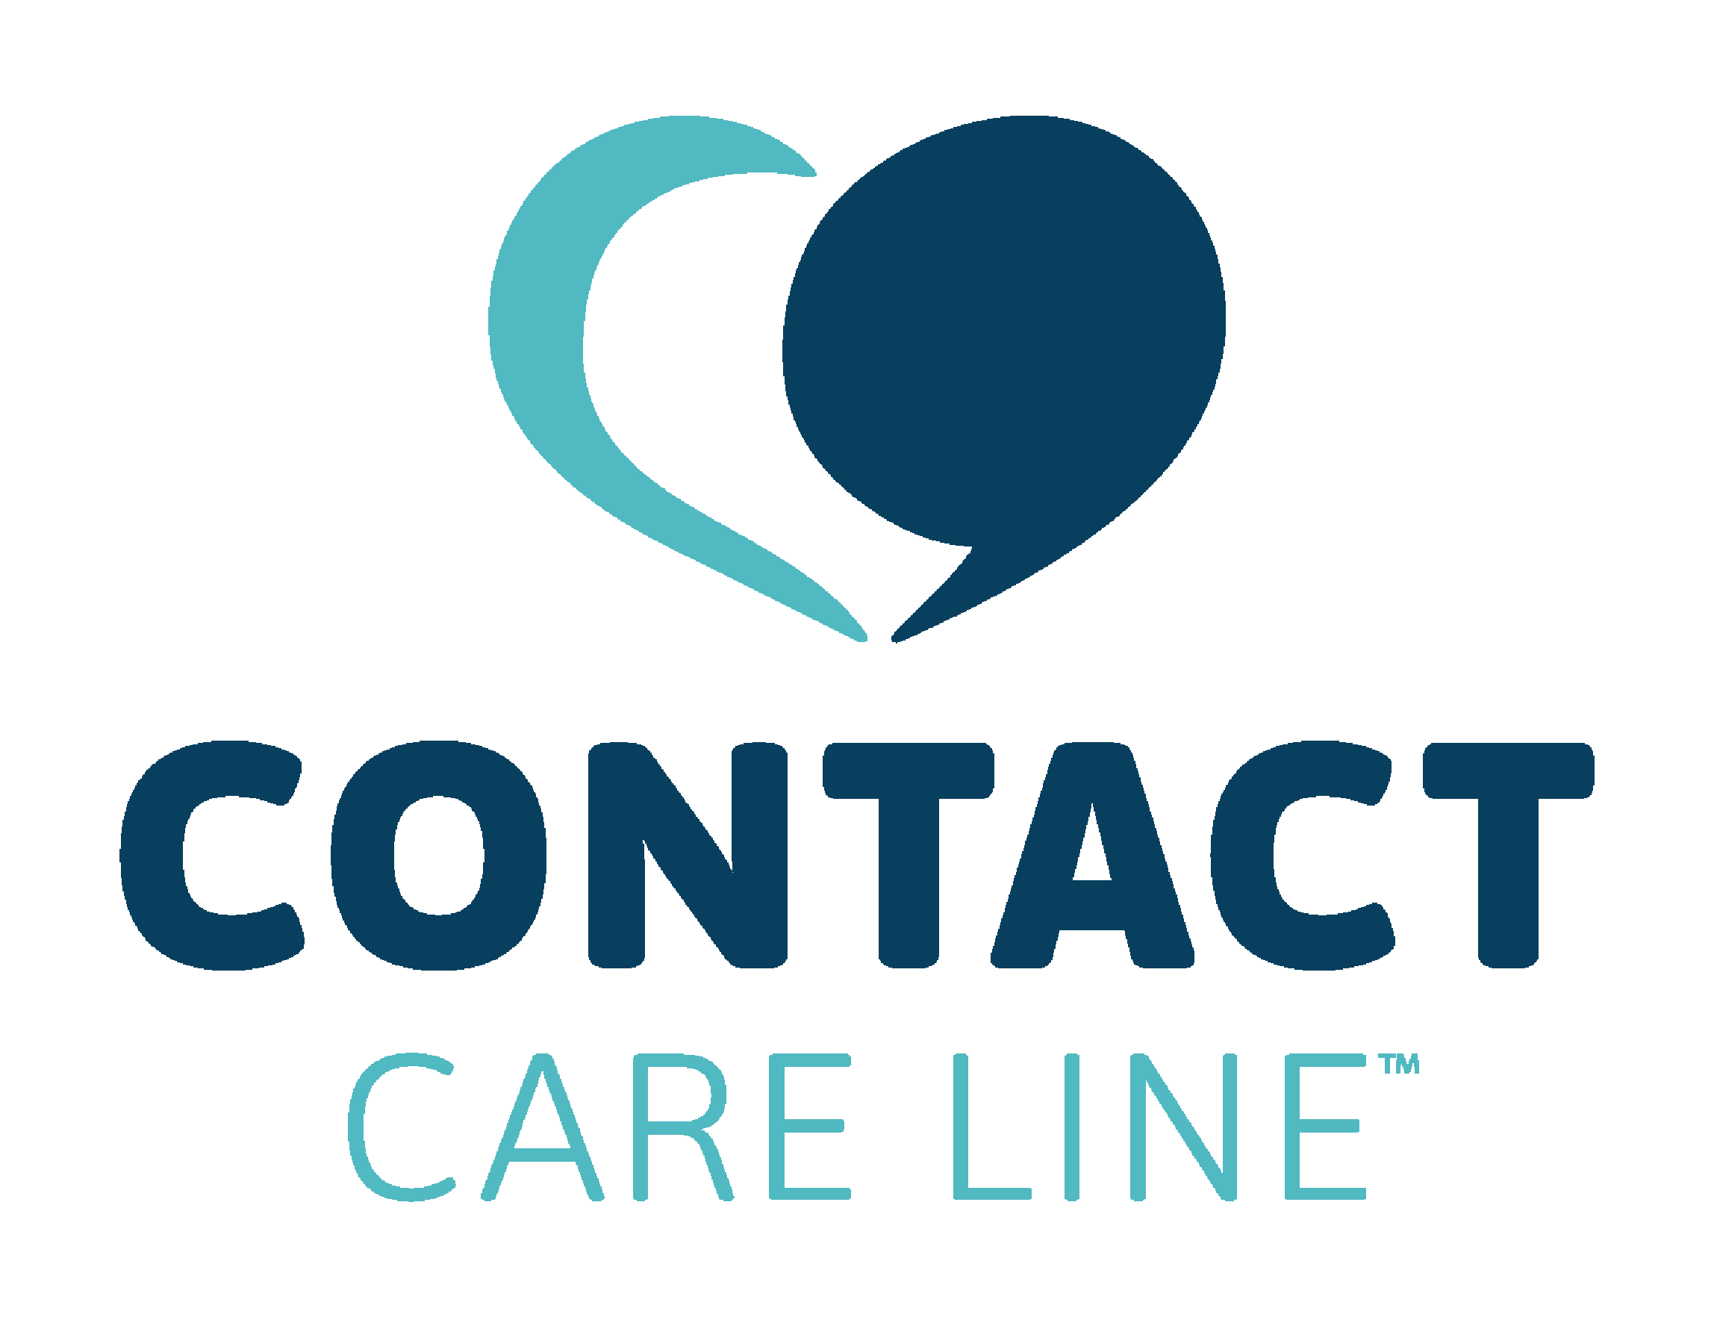
Annotated Bibliography
Crisis Intervention & Suicide Prevention
Recommended Resources for Social Workers
Prepared for the eVOLve Conference · March 20, 2026

The selections were curated by CONTACT Care Line, the 988 Suicide & Crisis Lifeline center serving East Tennessee, based on resources commonly used in crisis-line training and counselor education. The fourteen titles below represent the most widely used and highly regarded texts in crisis line training and counselor education. Each entry includes a full APA citation and a brief annotation describing its relevance to crisis intervention and suicide prevention practice. A recommended reading ladder appears at the end, organized by practitioner experience level.
SUICIDE-SPECIFIC FOUNDATIONS
Jobes, D. A. (2016). Managing suicidal risk: A collaborative approach (2nd ed.). New York: Guilford Press.
This foundational text introduces the Collaborative Assessment and Management of Suicidality (CAMS) framework, shifting the clinician's role from authority-driven intervention to a genuinely collaborative partnership with the client. Essential for supervisors and advanced counselors who want to move beyond risk checklists toward meaningful therapeutic engagement with suicidal individuals.
Recommended for: Experienced Counselors & Supervisors
Joiner, T. E. (2005). Why people die by suicide. Cambridge, MA: Harvard University Press.
Joiner's Interpersonal Theory of Suicide—thwarted belongingness, perceived burdensomeness, and acquired capability—provides counselors with a coherent conceptual map for understanding suicidal pain. Reading this book transforms abstract risk factors into a clinically useful framework that can guide assessment conversations.
Recommended for: Experienced Counselors
Jamison, K. R. (1999). Night falls fast: Understanding suicide. New York: Knopf.
Written by a psychologist and mood disorder researcher who has personally navigated suicidality, this is one of the most humanizing accounts of suicide ever published. It blends science, history, and memoir to cultivate the deep empathy that crisis counselors require. Widely assigned as essential reading for new volunteers and counselors.
Recommended for: New Crisis Counselors
CRISIS INTERVENTION SKILLS
Shea, S. C. (2011). The practical art of suicide assessment: A guide for mental health professionals and substance abuse counselors. Hoboken, NJ: Wiley.
Shea offers rigorously practical interviewing strategies for working with suicidal clients, including the Chronological Assessment of Suicide Events (CASE) approach. This book is a go-to resource in risk-assessment training because it translates theory into the exact phrasing and sequencing of a clinical interview.
Recommended for: Experienced Counselors
Bryan, C. J. (2021). Cognitive behavioral therapy for suicide prevention (CBT-SP): Skills training manual. New York: Guilford Press.
Bryan's work focuses on brief, targeted interventions well-suited to the time-limited nature of crisis hotline and short-term counseling work. The skills are evidence-based and portable, making this an excellent practical companion for counselors who need structured, actionable tools for acute suicidal crises.
Recommended for: Experienced Counselors
LISTENING AND PRESENCE
Rogers, C. R. (1961). On becoming a person: A therapist's view of psychotherapy. Boston: Houghton Mifflin.
Rogers' articulation of unconditional positive regard, empathy, and congruence remains the philosophical bedrock of person-centered crisis intervention. Most crisis line training philosophies are rooted here, whether or not Rogers is explicitly cited. A must-read for understanding why how we listen matters as much as what we say.
Recommended for: New Crisis Counselors
Yalom, I. D. (2002). The gift of therapy: An open letter to a new generation of therapists and their patients. New York: HarperCollins.
Written as short, accessible reflections on the human dimensions of therapeutic work, this book is ideal for cultivating the self-awareness that crisis counselors need. Yalom's candor about presence, uncertainty, and the weight of the work offers permission for practitioners to embrace the complexity of helping.
Recommended for: New Crisis Counselors
Greenberg, J. (1964). I never promised you a rose garden. New York: Holt, Rinehart and Winston.
This semi-autobiographical novel traces a young woman's treatment for schizophrenia and remains a classic for building empathy and perspective about severe mental illness. Assigned widely in counselor education, it helps practitioners understand the interior experience of those in crisis from the inside out.
Recommended for: New Crisis Counselors
Nichols, M. P. (2009). The lost art of listening: How learning to listen can improve relationships (2nd ed.). New York: Guilford Press.
Nichols makes a compelling case that most people listen far less well than they believe—and that genuine listening is a learnable skill requiring intention and practice. For crisis counselors whose primary tool is the phone call, this book offers both the rationale and the concrete techniques for becoming a more attuned and effective listener.
Recommended for: New Crisis Counselors & Experienced Counselors
Fisher, J. (2024). The next conversation: Argue less, talk more. New York: Simon & Schuster.
Fisher, a trial attorney and communication coach, distills powerful principles for navigating high-stakes conversations with clarity and de-escalation rather than confrontation. The accessible, practical framing makes this book particularly useful for crisis counselors who need tools for redirecting volatile or resistant callers without increasing tension.
Recommended for: New Crisis Counselors & Experienced Counselors
TRAUMA AND EMOTIONAL PAIN
van der Kolk, B. A. (2014). The body keeps the score: Brain, mind, and body in the healing of trauma. New York: Viking.
Van der Kolk's landmark work explains how traumatic experience is encoded in the nervous system—not merely in memory—fundamentally reshaping how we understand and respond to trauma survivors. Because so many crisis callers present with trauma histories, this book is widely considered essential background knowledge for crisis counselors and supervisors alike.
Recommended for: Experienced Counselors & Supervisors
Herman, J. L. (1992). Trauma and recovery: The aftermath of violence—from domestic abuse to political terror. New York: Basic Books.
Herman's foundational text established the field's understanding of complex trauma, survivors' responses, and the conditions necessary for recovery. Its clinical insight and moral clarity make it one of the most influential books ever written on the subject. Supervisors and advanced clinicians will find it indispensable for contextualizing the crises they encounter.
Recommended for: Supervisors
EMPATHY AND MEANING-MAKING
Brown, B. (2012). Daring greatly: How the courage to be vulnerable transforms the way we live, love, parent, and lead. New York: Gotham Books.
Brown's research on vulnerability and shame offers crisis counselors a deeper understanding of the emotional exposure clients experience when reaching out in crisis. This book also helps practitioners examine their own relationship with vulnerability—a prerequisite for authentic, non-judgmental engagement with callers.
Recommended for: New Crisis Counselors
Frankl, V. E. (1959). Man's search for meaning. Boston: Beacon Press.
Frankl's account of survival in Nazi concentration camps and his development of logotherapy—the pursuit of meaning as a primary human drive—offers profound insight into why people continue living in the face of unbearable suffering. Often used in counselor reflection assignments, this slim volume speaks directly to the heart of suicide prevention work.
Recommended for: New Crisis Counselors

RECOMMENDED READING LADDER
The following structure is suggested for organizations building a progressive professional development pathway in crisis intervention.
Level 1 — New Crisis Counselors
- Jamison — Night Falls Fast
- Yalom — The Gift of Therapy
- Frankl — Man's Search for Meaning
- Rogers — On Becoming a Person
- Nichols — The Lost Art of Listening
- Fisher — The Next Conversation
Level 2 — Experienced Counselors
- Joiner — Why People Die by Suicide
- Shea — The Practical Art of Suicide Assessment
- Bryan — Cognitive Behavioral Therapy for Suicide Prevention
- van der Kolk — The Body Keeps the Score
Level 3 — Supervisors
- Jobes — Managing Suicidal Risk
- Herman — Trauma and Recovery

All annotations prepared for the eVOLve Conference, March 20, 2026. Citations follow APA 7th edition format.

